College Network Security & Hybrid Access Project
Cisco Virtual Internship Program – Cyber Security Stream (2025) –MANJITH MUGUNDAN T A URK23CS1011

Project Overview
The project was created under the Cisco Virtual Internship Program 2025, under the Cyber Security stream, to meet the increasing challenge of securing academic networks in the digital era. Schools, especially colleges, are becoming more and more attractive targets for cyber-attacks because of the amount of sensitive academic, administrative, and personal information they store.
The main goal of this project was to evaluate, architect, and enhance the security of the current network of the college, bringing it in line with the latest cybersecurity standards and keeping in mind restrictions like low budgets and small IT staff.
The effort was methodically separated into three main phases:
- Security Audit & Attack Surface Analysis – Through evaluation of vulnerabilities, misconfigurations, and risks.
- Hybrid Network Model for Secure Remote Access – Designing a flexible but secure model enabling on-campus and off-campus access.
- Web Access Policy Design & Enforcement – Designing internet usage rules, balancing security with academic productivity.
The end result was a secure, segmented, and scalable network that fosters collaborative academic work while providing strong protection against internal and external cyber-attacks.

Problem Statement
The current flat network topology of the college presented several challenges that resulted in operational inefficiencies as well as security threats. The major issues found were:

Lack of Proper Security Audits:
Since there were no proper audits, vulnerabilities could not be easily detected and documented. This lack of visibility posed an increased risk of lateral movement attacks, wherein one compromise could propagate across the entire network.

Hybrid/Remote Access Requirement:
The post-pandemic educational model necessitates hybrid instruction and administration. Teachers tend to work from home and require access to research servers, e-learning platforms, and administrative databases. Without an effective VPN-based solution, remote access is open to cyber threats.

Unrestricted Internet Usage:
The unrestricted character of internet usage within the college resulted in problems such as:

  - Abuse of bandwidth by non-academic use (e.g., streaming, gaming).
  - Greater exposure to malware and phishing attacks.
  - Decreased productivity as a result of social media distraction during study times.
To address these challenges, an organized cybersecurity project was implemented with layered protection, segmentation, monitoring, and access control measures.

Part 1 – Security Audit & Attack Surface Analysis
The initial step was the analysis of the current infrastructure through Cisco Packet Tracer simulations and manual examination of network configurations.

Key Observations (Aligned with Topology):
- Departmental Segmentation:
Each department (Science, Engineering, Library, IT, Administration, etc.) has its own zone within the topology. But there were some "flat" areas where cross-departmental access was uncontrolled. One weak zone might be exploited by attackers to pivot across the network.

Core Interconnection Point:
The core router/firewall at the center controlled all interconnects. Although centralization offers efficiency, it poses a single point of failure threat. In case of compromise, the whole college network would be taken down.

Wireless Access Points (APs):
There were several wireless APs connected to departmental areas. In the absence of firm authentication and encryption, rogue devices or unauthentic users could be let into the network through these APs.

Controls in Place:
Firewalls and ACLs existed but were not maximized. IDS/IPS systems were not systematically implemented across departments. Authentication servers were decentralized, resulting in inconsistent policy enforcement.

Recommended Countermeasures:
- Use VLAN-based segmentation at the switch level to limit lateral movement.
- Set department-specific ACLs to strictly enforce role-based communication policies.
- Use IDS/IPS sensors at the core to inspect traffic patterns across all zones.
- Secure wireless access by implementing WPA3 encryption and 802.1x authentication.
- Implement centralized AAA (Authentication, Authorization, Accounting) servers.

Deliverables:
  - Detailed Audit Report – enumerating vulnerabilities, risks, and misconfigurations.

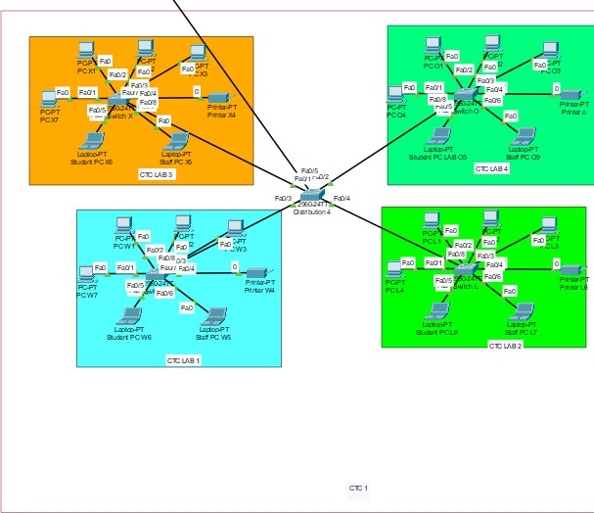
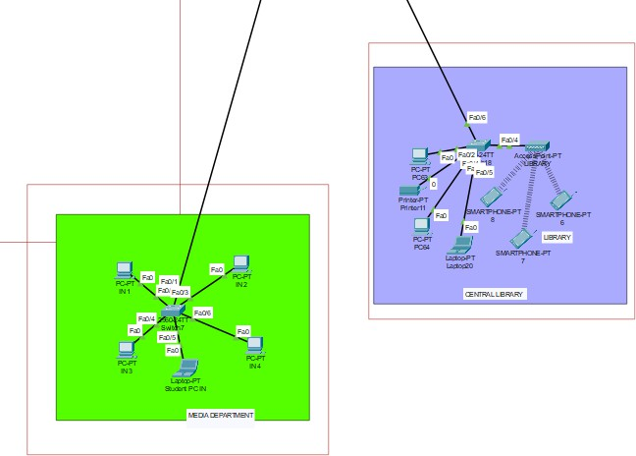
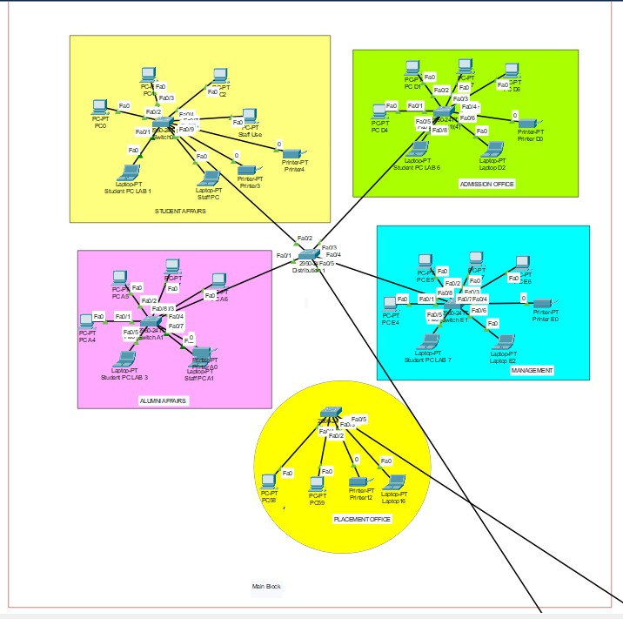
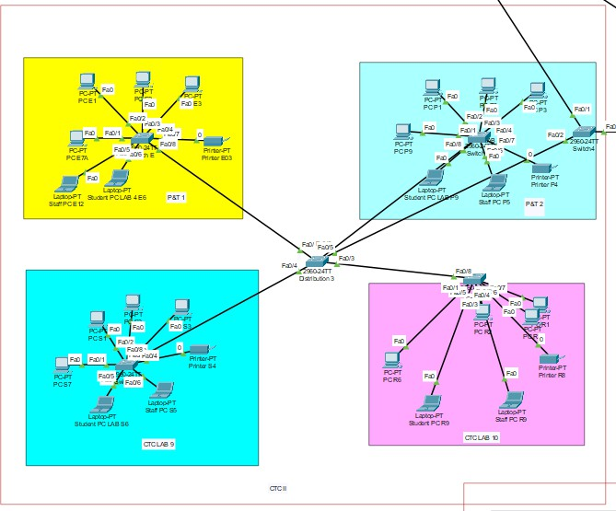
  - Enhanced Network Topology Diagram – with clear indication of vulnerable areas and flat areas.

Output:
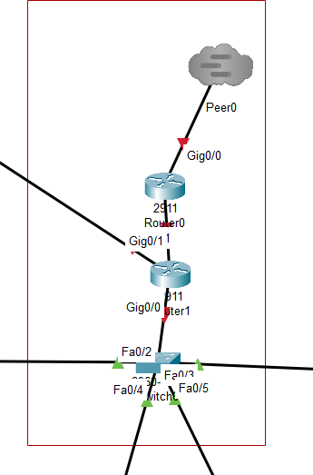
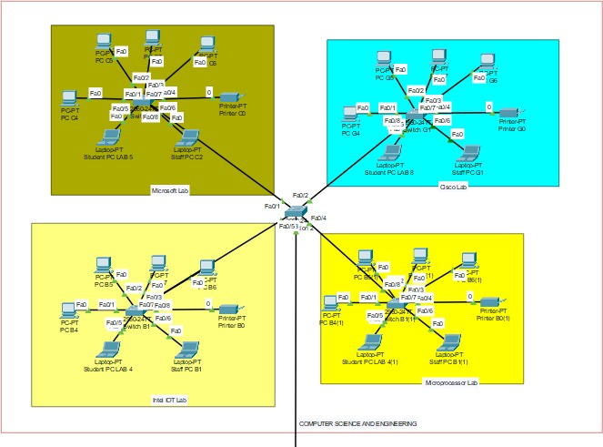

Part 2 – Hybrid Network Secure Architecture
Following the audit, the next task was to create a secure hybrid network architecture that accommodates on-campus activities and remote access for faculty/staff.

Hybrid Architecture Features:
- Central VPN Gateway at Core:
Administrative staff and faculty members are able to log in securely remotely through VPN tunnels. This guarantees that data in transit is encrypted.

Role-Based Segmentation:
The design was augmented with crisp VLAN segmentation:
  - Faculty VLAN: Academic resource access and research databases.
  - Student VLAN: Restricted to e-learning interfaces, labs, and intranet.
  - Guest VLAN: Internet-only with heavy controls.
  - Admin VLAN: Access to sensitive systems such as payroll and student information.

Policy Enforcement Zones:
Every link to the core firewall is filtered by policy enforcement filters, and any unknown traffic is prohibited at the point of entry.

Authentication Flow:
All users must go through centralized authentication (LDAP/RADIUS/Active Directory) before accessing. Remote VPN users need multi-factor authentication (MFA) for enhanced security.

Benefits:
  - Faculty can work securely off-campus without compromising internal servers.
  - Students are kept from accessing restricted areas.
  - Guest users have supervised and limited access to conserve bandwidth.

Deliverables:
  - Technical Documentation describing selected technologies, threats mitigated, and justification of hybrid architecture.

Part 3 – Web Access Policy & Enforcement
The third and last phase of the project dealt with secure and productive use of the internet in all zones.

Web Access Policy (Role-Based):
- Faculty:
  - Complete access to research journals, research portals, and collaboration tools.
  - No prohibitions on valid academic/research-oriented websites.

Students:
  - Limited access during study time (blocked or limited social media, gaming, and entertainment).
  - Priority bandwidth allocation to e-learning applications and intranet.

Guests:
  - Limited browsing functionality.
  - Tight activity monitoring.
  - Blocked access to harmful or non-educational websites.

Enforcement Mechanisms:
  - DNS Filtering: Blocks blacklisted and malicious domains.
  - Layer 7 Firewalls: Deep packet inspection to prevent application-level abuse (e.g., proxy avoidance, torrent downloads).
  - Logging & Monitoring: All requests logged for audit trails and forensic evaluation.
  - Real-Time Alerts: Anomalous activity issues notifications to IT managers.

Deliverables:
  - Policy Document – clear, easy-to-understand writing for employees and students.
  - Updated Network Diagram – with firewall and filtering integration included.
  - Enforcement Flow Explanation – step-by-step journey of how traffic is filtered, logged, and responded to.

Key Security Features Implemented
  - Network Segmentation: VLANs mitigate lateral movement risk.
  - VPN for Hybrid Access: Remote users access securely without exposing core servers.
  - DNS Filtering & Layer 7 Firewalls: Guards against malicious websites and unauthorized programs.
  - Role-Based Access Control (RBAC): Various roles mapped to varying levels of access.
  - Logging, Monitoring, and Alerts: Round-the-clock monitoring ensures rapid detection and response.

Tools & Technologies Used
  - Cisco Packet Tracer: network design and simulation.

  - ACLs, VLANs, Firewalls: segmentation and enforcement.
  - IDS/IPS Tools (e.g., Snort, Suricata): intrusion detection.
  - VPN Solutions (IPSec/SSL VPN): remote faculty access.
  - DNS Filtering & Proxy Services: for controlling browsing.
  - Authentication Servers (AAA): for identity and policy enforcement on a centralized basis.

Conclusion

The project effectively converted a flat, insecure college network into a secure, segmented, and hybrid-ready one. The incorporation of audit-driven enhancements, hybrid access solutions, and stringent web access policies makes the network both cyber-resilient and conducive to academic productivity.

Through the balance of security, usability, and price, the proposed design makes it possible for colleges to implement a cyber-resilient network model without overshooting resource limitations.

